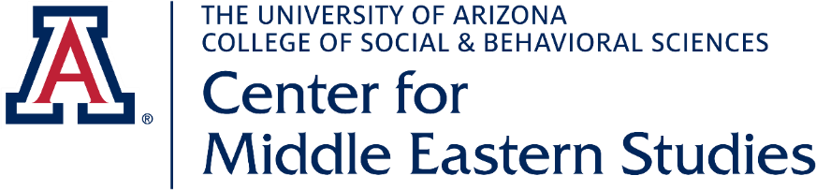
Application for Outreach Scholarship Program

The University of Arizona’s Center for Middle Eastern Studies (CMES) has established the CMES Outreach Scholarship Program for UA students in the amount of $250. The aim of the program is to bring a greater understanding of the Middle East to the Arizona community. During the period of the scholarship, outreach scholars will participate in two speaking engagements in the community in response to requests from community groups (such as service organizations, religious groups, and local government organizations), schools (K-12 and community colleges), and in programs organized by CMES. DUE TO COVID-19 RESTRICTIONS, THESE ENGAGEMENTS MAY BE ONLINE.

- Name: _____________________________________________________________
- Email address: ______________________________________________________

- Cell phone number: ___________________________________________________

- Country of Citizenship: _____________________________

Check the immigration status that applies to you:
______ U.S. citizen or permanent resident
______ F-1 visa
______ J-1 visa (If J-1, who issued the DS-2019: _______________________)

- Do you have full funding (tuition, books, living expenses, etc.)? _______________

- Year of study (freshman, senior, graduate student, etc.: ______________________

- Major: ____________________________________________________________

- Availability (days/times that you are usually free – when you don’t have classes, work, or other scheduled activity):

- On a separate page, write a 300-word essay summarizing why you wish to be a CMES Outreach Scholar and what you think you can do for our program.

----Email your complete application to adeli@email.arizona.edu.
Deadline: September 9, 2020.

